Four Recorded Moments In the Gospel Story of Universal or Monadic Realization

ROC, 27

There are in the Gospel story (as testimony to this divinely progressing unfoldment) four recorded moments wherein this universal or monadic realization showed itself. Let us look at each one of them for a moment:

1. There is, first of all, His statement to His parents in the Temple, "Wist ye not that I must be about my Father's business?" We should note here that He was twelve years old at the time and, therefore, the work with which He had been occupied (as a soul) was finished; twelve is the number of completed work, as witness the twelve labours of Hercules, another Son of God. The symbolism of His twelve years is now replaced by that of the twelve apostles, the symbol of service and sacrifice. He was also in the Temple of Solomon, which is the symbol of the perfect life of the soul, just as the Tabernacle in the wilderness is the symbol of the imperfect ephemeral life of the transient personality; Christ was, therefore, speaking on soul levels and not only as the spiritual man on Earth. He was also serving, when He spoke these words, as a working Member of the Spiritual Hierarchy, for He was found by His parents teaching the priests, the Pharisees and the Sadducees. These points all indicate His recognition of His work as a World Teacher, becoming conscious, for the first time in His physical brain, of divine intention or of the divine will.

2. Next comes His statement to His disciples: "I must go up to Jerusalem," after which we read that He "steadfastly set His face to go" to that city. This was the intimation to them that He now had a new objective. The only place of complete "peace" (which is the meaning of the name "Jerusalem") is the "centre where the will of God is known." The spiritual Hierarchy of our planet (the invisible Church of Christ) is not a centre of peace but a very vortex of loving activity, the meeting place of energies coming from the centre of the divine will, and from humanity, the centre of divine intelligence. Christ had oriented Himself to that divine centre which has, in the ancient Scriptures, been called the "place of serene determination and of poised, quiescent will." This statement marked a point of crisis and of determination in the life of Christ, and proved His progress towards divine fulfilment.

3. Then in the Garden of Gethsemane He said, "Father, not My will but Thine be done," thus indicating His realisation of divine destiny. The meaning of these words is not (as is so often stated by Christian theologians) a statement of acceptance of pain and of an unpleasant future and of death. It was an exclamation, evoked surely by His realisation of the universal implications of His mission and the intense focusing of His life in a universal sense. The Gethsemane experience was an experience uniquely possible only to those Sons of God Who have reached His rare point in evolution; it had no real relation to the Crucifixion episode, as the orthodox commentators emphasize.

4. The final words of the Christ to His apostles were, "Lo, I am with you all the days, even unto the end of the age" or cycle. (Matt. 28.20.) The important word is "end." The word used is the Greek "sun-teleia," which means the end of the time period, with another immediately following after (what would be called the end of a cycle). In Greek the final end is another word "telos." In Matt. 24.6, "but the end is not yet," the other word telos is used for it means "the end of the first period has not yet been reached." Here He was speaking as the Head of the spiritual Hierarchy and expressing His divine will (at-one now with the will of God) to inform and pervade continuously the world of men with His overshadowing consciousness. It was a tremendous affirmation, sent forth upon the energy of His developed will, His all-inclusive love and His intelligent mind. This affirmation has made all things possible.

It was also to the magnetic power of the will that Christ referred when He said, "I, if I be lifted up, will draw all men unto Me." This had no reference to the crucifixion but to the magnetic will of the Christ to draw all men, through the life of the indwelling Christ in every heart, out of the world of material values into the world of spiritual recognitions. It did not relate to death but to life; it had no reference to the Cross but to the resurrection. In the past, the keynote of the Christian religion has been death, symbolised for us in the death of Christ and much distorted by St. Paul in his effort to blend the new religion which Christ brought, with the old blood religion of the Jews. In the cycle which Christ will inaugurate after His reappearance, the goal of all the religious teaching in the world will be the resurrection of the spirit in mankind; the emphasis will be upon the livingness of the Christ nature in every human being, and upon the use of the will in bringing about this living transfiguration of the lower nature. The proof of it will be the risen Christ. This "Way of Resurrection" is the radiant Way, the lighted Way which leads from one great expression of divinity in man to another; it is the way which expresses the light of the intelligence, the radiant substance of true love, and the inflexible will which permits of no defeat or withdrawal. These are the characteristics which will be declarative of the Kingdom of God.

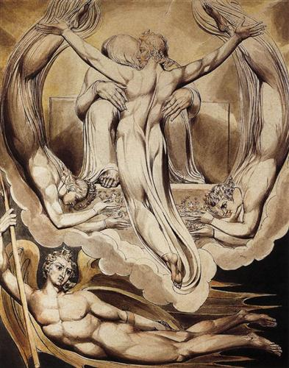
Christ as the Redeemer of Man – Wm Blake

֍

