Venus Orbit
http://imgur.com/gallery/oXuB6
http://ensign.editme.com/t43dances

The planets in the heavens move in exquisite orbital patterns, dancing to the Music of the Cosmos. There is more mathematical and geometric harmony than we realize. The idea for this article is from a book Larry Pesavento shared with me. The book, 'A Little Book of Coincidence' by John Martineau, illustrates the orbital patterns and several of their geometrical relationships. . Take the orbits of any two planets and draw a line between the two planet positions every few days. Because the inner planet orbits faster than the outer planet, interesting patterns evolve. Each planetary pairing has its own unique dance rhythm. For example, the Earth-Venus dance returns to the original starting position after eight Earth years. Eight Earth years equals thirteen Venus years. Note that 8 and 13 are members of the Fibonacci number series. Earth: 8 years * 365.256 days/year = 2,922.05 days Venus: 13 years * 224.701 days/year = 2,921.11 days (i.e. 99.9%) Watching the Earth-Venus dance for eight years creates this beautiful five-petal flower with the Sun at the center. (5 is another Fibonacci number.)

http://www.skyscript.co.uk/venusrose.html

The magical geometry that exists between the cycles of the planets has been a source of fascination and mystery for centuries. Lately, the adoption of the heliocentric viewpoint has caused many of these marvels to pass by the interest of astronomers. The pattern of Venus around the Earth portrays a 5-petalled rose when viewed from the geocentric position. Every 8 years, when the Earth and Venus 'kiss' to form another petal, Venus presents the same face to the Earth. The dance of the planets: their retrograde motions, synodic periods, distance and orbits present us with patterns that resonate to their essence. Kepler understood such patterns as a mathematician aware of the mystical qualities of the universe. The patterns of Venus are extremely beautiful - the heart and the rose. They reveal the essence of Venus in her role of celestial guardian of love and beauty to those of us here on Earth.

Venus
Venus has an eight-year rhythm, which formed the subject of the world’s oldest astrological text, a Venus-tablet from Nineveh. It was part of a series called Enuma Anu Enlil, the ‘Book of the Gods of Heaven and Earth’, and was dated to the 17th century BC. It effectively recorded the five synodic periods of Venus, giving a series of ten omens over the eight-year cycle through the pattern of Venus’s appearance and disappearance from view. [1]
To the astronomer Johannes Kepler, the musical interval generated by Venus and Earth was a ‘sixth’, given by dividing a string in the fraction 5/8. [2] He said the relation was a ‘marital’ one and varied between the ‘masculine sixth’ G# - E and the ‘feminine’ one of Gb - E. [3] This ratio of 5 to 8 is the key to the pattern traced by Venus against the stars.
Venus traces a pentagon shape in the sky over ten meetings with the Sun; it does this by moving, between each ‘inferior’ conjunction, exactly 1.6 times around the zodiac, and the time it takes to do this, 584 days, is its synodic period. [4] The pentagon shape is traced around the zodiac in five such synodic periods, which is 7.993 years or 8 years to a fraction of a day. Venus returns to the same portion of the zodiac after ten solar conjunctions, over a period of exactly 8 years.
The rotation rate of Venus on its own axis was not discovered until 1967 by means of radar. This was able to peer through the dense mists surrounding the planet, and find a rotation period of precisely two-thirds of an Earth-year, or 243 days. Strangely enough, it was in the opposite direction to its rotation around the Sun. This meant that, in an eight-year period, Venus revolves exactly twelve times on its own axis. The numbers 5, 8 and 12 are here interacting.
It follows from this that, each time Venus comes nearest to Earth in an inferior conjunction, the same part of its surface will be pointing towards Earth. Over one synodic period, Venus revolves 1.6 times around the zodiac, while it will have revolved on its axis 360° x 584 / 243 = 2 x 360° + 145°, ie., it will be 145° from its previous position. That is two quintile angles — it is helpful, indeed vital, to visualise the biquintile division here. As it has then gone three fifths around the zodiac or 216°, that is three quintile divisions, in the other direction, it is again pointing towards Earth, and this is within less than one degree! One cannot do this computation any more acurately because it involves an approximation of ignoring the elliptical nature of the orbits. Astronomers surmised that some mysterious resonance was operating to produce the tie-up. To quote from a book by the Royal Observatory at Greenwich,
“There are too many such numerical coincidences in the Solar System for this to be mere coincidence, so it seems that it is the Earth which controls the length of the Venus day, possibly through tidal interaction” [5]
But there is no such tidal interaction, as far as anyone knows. Others have referred to the phenomenon as ‘synodic resonance’. [6]
An Australian meteorologist discovered that the Earth’s magnetic field quietened down over the days when Venus came closest to Earth (ie., the geomagnetic storm index tended to minimise during the Venus inferior conjunctions). [7] To account for this it was supposed that Venus had a strong magnetic field which could interfere with or affect the Sun’s magnetism as it streamed towards Earth; however it turned out that this was not the case, and Venus had only a weak magnetic field, so how could it exert this mysterious tranquillising effect? No-one could answer this, and so the discovery has been forgotten.

The Rose

The Rose Pattern: This 8-year cycle is woven in sidereal space, with Earth at the centre. It comprises 5 synodic periods.
The pattern made by Venus relative to Earth was hardly seen or described by astronomers prior to the mid-1980s, but has emerged only in the last decade from the computers of astrology enthusiasts! [8] The experience of this mandala is recent, it cannot be found in old books. After all, astronomers are not concerned with the geocentric perspective which it involves. In Britain, this orbit-pattern was described by Michael E. O’Neill in 1984 or thereabouts. Before that, some credit for priority of this beautiful discovery belongs to Astro-Computing Services in the U.S.[9]
The rose-pattern shown revolves very slowly in sidereal space, moving by a degree or so every 8-year cycle against the stars. The planet Venus revolves in the opposite direction to that of its orbit, such that dancers performing the ‘dance of Venus’ come to be facing towards the centre (ie., Earth) at each point of nearest approach, then revolve so that they come facing the centre three more times between each of these positions.
The pattern shown is circular, since both Venus and Earth have orbits of very low eccentricity, ie., almost circular. All the other planets have more elliptical orbits: Mars is about ten times more elliptical in its motion around the Sun, and so a diagram of the kind shown for Mars would lack any such symmetry.
This geocentric plot is free from any interpretive assumptions, such as that the Earth orbits around the Sun, and just shows the uninterpreted motion of Venus around the zodiac, as seen from Earth — what an astronomer sees every 8 years, by measuring distance as well as position. However, the mandala does not indicate the disappearance from view of Venus every time it draws into a solar conjunction.

The Heart

The Heart-Motif: just over one synodic period. The dots denote 50-day intervals. The two loops are the inferior conjunctions, showing retrograde motion, and form a biquintile angle.
A small portion of the rose-pattern shows just one of the five ‘heart’ shapes woven by Venus in its motion against the stars. Each dot in the figure signifies a daily position and larger dots have been inserted every fifty days. Thus a heart-shape takes just over 400 days to form, compared with the synodic period between two loop formations of 584 days.
These diagrams help us to visualise Venus’s periods of retrograde motion, as occur only during close approach to Earth, ie., at each inferior solar conjunction. Venus is retrograde for a mere 7% of the time, only about half as often as Mercury, for comparison. For forty days at a time, Venus reverses direction as seen against the stars, so that it retrogrades over the same part of the zodiac every eight years.
If a dancer were to start at the base of the heart shape, then in order to arrive facing towards the centre when she reached the inferior conjunction position at the top, she would have to start by facing south-west (South-55°-West). She then rotates clockwise. One notes that such an angle cannot be calculated mathematically, but can (I believe) only be derived from computer diagrams such as the one shown. Also, as the diagram shows, the dancer would proceed much more slowly over the inferior conjunction positions.
Astronomers are fond of describing Venus as a barren, rock-strewn planet surrounded by boiling sulphuric acid vapour, when sneering at the tenets of astrology; implying that astrologers are incapable of looking at facts straight in the face. It would help them to develop beyond so sadly limited a viewpoint if they were to contemplate the marvellous significance of the Venus orbit. Michel Gauquelin keeps rather quiet about his discovery that Venus is linked to the births of eminent musicians and artists throughout Europe. Surely the harmonies generated by the orbit of this planet enhance one’s appreciation of this discovery. [10]
Notes & References:
 | 1 ] | From The Omens of Babylon, Astrology and Ancient Mesopotamia, Michael Baigent, 1994, p.59.  Back to text
 | 2 ] | Harmonices Mundi, Johannes Kepler 1620, Book V.Back to text
 | 3 ] | Harmonies of Heaven and Earth, Joscelyn Godwin 1987, p.147.  Back to text
 | 4] | The synodic period derives from the sidereal periods of Earth and Venus interacting, as 1/224 - 1/365 = 1/584 days, where 224 days is Venus’s sidereal period.  Back to text
 | 5] | The Greenwich Guide to the Planets, S.Malin, 1987, p.40.  Back to text
 | 6] | The Planet Venus, G.Hunt and P.Moore, 1982, p.82;The realm of the Terrestrial Planets, Z.Kopal, 1979, p.179.  Back to text
 | 7] | E.K.Bigg ‘Lunar and Planetary Influences on Geomagnetic Disturbance’, Journal of Geophysical Research, 1963, 68, p.4099.  Back to text
 | 8] | The diagrams were computer generated by Michael O.Neill, U.K., and are reproduced with his permission.  Back to text
 | 9] | Astro-Computing Services in the U.S. have been distributing the computer designed ‘Planetary Mandalas’, made from a program written by Neil Michelson, since the mid-1970s; however, these did not include the above Venus-pattern. Neil Michelson told the writer: “I saw a hand plot of this cycle [ie., of Venus] about six years ago but I can’t remember the name of the person who had drawn it”.  Back to text
 | 10] | Les Hommes et les Astres, M. Gauquelin, 1960. His other publications omit this fact, because (he told the writer) it was not constant between European nations: in one country musicians would emerge from his statistics as ‘born under Venus’ while in another it would be artists. For a more recent evaluation see ‘Planetary Correlations with Musicians, Painters and Writers’, by Prof. Suibert Ertel,Correlation, June 1987, pp. 4-17.  Back to text

Nick Kollerstrom has a Cambridge science degree and has worked as a physics schoolteacher. He is recognised throughout the astrological community for his pioneering studies that have brought his scientific background into exciting fields of research on planets, plants and metals. He has been actively involved in the study of planet-metal associations and other matters of a Hermatic nature for 30 years, and has lectured on these subjects since 1975. His work in medical research resulted in his book Lead on the Brain - a plain guide to Britain's No 1 pollutant. His investigation of lunar effects upon plant growth led in the 1980s to his gardener's guide Planting by the Moon and the popular annuals Gardening and Planting by the Moon. Nick Kollerstrom's latest title, Crop Circles: The Hidden Form, published by Wessex books, offers a new way of experiencing the crop circle mystery, through the geometry of the forms revealed in crops.
For further details of Nick Kollerstom's work, visit his website at The Anthroposophical Society.

© Nick Kollerstrom

http://www.skyscript.co.uk

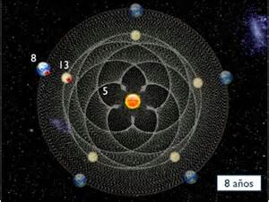

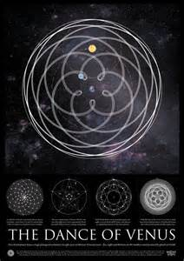

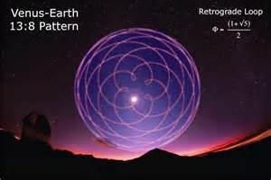

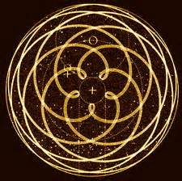

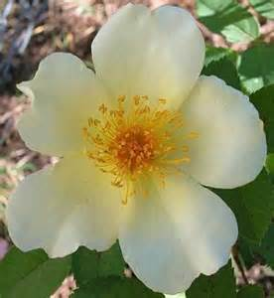
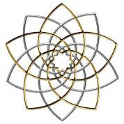

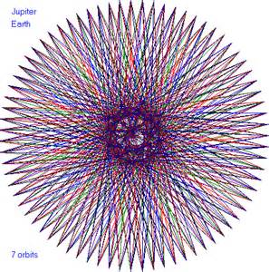

Article:

http://3.bp.blogspot.com/_H_YV13bgS2s/SKa_XTk5G4I/AAAAAAAAAFE/DWBaC-Efj1M/s1600-h/Roskors+2.bmp

The Significance of the Rosicrucian Five Petaled Rose
by GH Frater SR

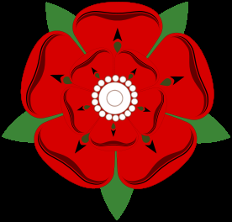
One of these details that was revealed through the publication of thevideos from the 100 Year Centennial Jubileum Celebration of the Rosicruian Order of Alpha et Omega was the five petaled rose born upon the Banner of the East, which has raised some questions of why this modification has come about and where we are to find its roots. And because of Aleister Crowley's rendition of the Unicursal Hexagram some people have even been so bold as to identify this to reflect a Thelemic philosophy of some sorts.
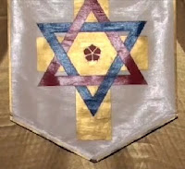
The Reformed Banner of the East
The task of this little essay is to reveal the true significance of this important and essential symbolism. The five petaled rose upon the Banner actually has a Rosicrucian significance, not Thelemic nor any other. Now let me explain why. The rose of five petals is actually a wild flower because wild roses has five petals. Furthermore, all roses have their petals grouped in multiples of five. Thus the geometrical pattern for the rose, because of the number 5, is the Pentagram or Pentangle. Hence, it is a symbol of the Four Elements and Spirit, or Quintessence.
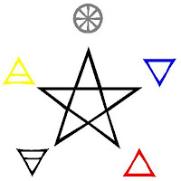
The Pentagram of Elements
I would argue that the rose actually is the premiere symbol of Spirit as it is the fifth principle crucified upon the Cross of the Four Elements (se below). As corresponding to the Pentagram, it is also the symbol of the Microcosm, or man. Hence its five petals correspond to the five senses, as do the Elements.
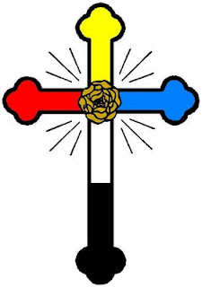
©Tomas Stacewicz

Note that the rose upon the reformed Banner of the Rosicrucian Order of Alpha et Omega points with one petal upward, as with the Pentagram. This signifies that Spirit surmounts the Four Elements and dominates their natures; Spirit over matter. Also note that the Thelemic rose of the Unicursal Hexagram is reversed (se below), as with the averse Pentagram where Spirit is subdued under the materialism of the Elements; matter over Spirit. This constitutes a fundamental difference which proves that the Reformed Banner has nothing whatsoever to do with the Thelemic symbol in question.
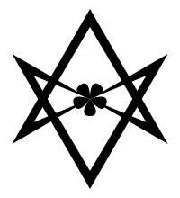
Unicursal Hexagram of Thelema
The rose is also sacred to Venus and Isis and in this instance it is interesting to note that the Pentagram traditionally has been associated with Venus, the bright star of morn, but also the evening star. Interestingly enough during certain times of the year the celestial motions of Venus sketch a pentagram in the sky, as plotting the recurrence of Venus' westward elongation from the Sun, over six consecutive synodic periods, will create the points of a Pentagram.
As it is associated with Venus the rose amongst other things signifies love, and also sexuality. According to Paul Foster Case, the famous Golden Dawn Adept, this links the symbol of the rose to desire and the secret force of which Venus and the metal copper are symbols. As a crucified rose it signifies that the desire nature of man, according to Case, has been unified with the One Law that is the basis of all manifestation. This basically means that desire or lover will of man has been subjected to the True Will of the Highest. The five petaled rose is therefore the symbol of completion and perfection, which is further emphasised by its association with the golden ratio through the Pentagram.
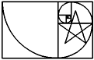
The Golden Ratio and the Pentagram
The significance of Isis also has a deeper Hermetic meaning which is not permissible for me to reveal here. But the red petaled rose is also the symbol of Osiris (which is resurrected by Isis) and signifies blood, as is confirmed in the Mystical Repast of the Neophyte Grade where Osiris says that “the scent of the Dying Rose is as the repressed Sigh of my suffering”. In Christian symbolism the five petaled rose represents the five wounds of Christ, which thus directly links it with Tipharet and the mystery of the crucifixion of the Adeptus Minor 5°=6° Grade.
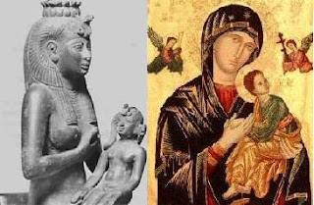
Isis and Mary

Some say that the five petaled rose also represents the idea of virgin birth or immaculate conception, which again is a reference to Isis and the conception of the child Horus (which was conceived without the fallos of Osiris), since a dog rose doesn’t need cross pollination to create the fruit of the tree. There's lots of similarities to be found between the myths of the Virgin Mary and Isis Mighty Mother. The five petaled rose was also the symbol of the great reformer Martin Luther, who some argues was either a inspiration to the Rosicrucian fraternity or was himself a member of that movement. I have written about this connection elsewhere on this blog.
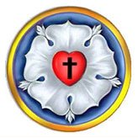
The Seal of Martin Luther
The rose has been in use by the Christian Church for millennia, in connection with the Cross symbolism. The term rosary, which means “garland of roses”, is well established in this context and both refer to a necklace with beads and to devotional prayer or mediation. But the five petaled rose especially refers to the reformed Church or protestant Christianity, as advocated by the Rosicrucian manifestos. This connection between Lutheranism and the Rosicrucian movement is emphasized by the special symbol of the Rosicrucian fraternity (see below), which can be seen on the membership roll of the Ordo Rosæ Rubeæ et Aureæ Crucis or R.R. et A.C.

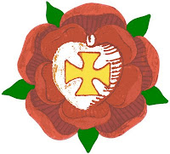
©Tomas Stacewicz
All this Christian Esoteric connections with the symbol of the rose upon the Rosy Cross is a further proof that it has nothing to do with Thelema, which advocates the downfall of Christianity by the medium of “the Great Beast”, or the prophet Aleister Crowley himself. Furthermore the rose signifies secrecy as can be read from the saying “sub rosa dictum”. It also corresponds with the Lotus flower, which is sacred to Harporcrates, the Egyptian god of silence. So basically, in this context, the rose represents the Arcanum or the secret mysteries.
So as can be seen, this simple symbol of the five petaled rose resumes a quite complex array of symbolism. Not to say that it since the 17th Century has been associated, together with the cross, with Rosicrucianism and not with Thelema (which was created during the last Century). This is why it was added to the Banner of the East in 1999 during the Reformatio Fraternitatis, which also shows that unlike in most orders, the Alpha et Omega is Rosicrucian and operative Hermetic in all three orders since that general reformation.
One has to remember that modern initiates of the Rosicrucian Order of Alpha et Omega practice Rosicrucian magic from the very beginning. This does not mean, however, that it do not preserve a strict separation of our First and Second Orders, or G∴D∴ and R.R. et A.C. respectively. On the contrary, the veil between the first and second Orders is even more pronounced since the general reformation of 1999 as the current material of study and practice of the Inner Order is hermetically sealed from the pale of the outside world, contrary to the profaned material of R.R. et A.C. from the yet older general reformation of 1888.
S∴R∴

http://www.golden-dawn.org/fivepetaledrose.html

